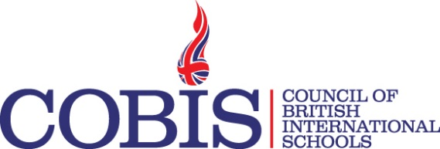
Webinar Title | Making Podcasts and Music Online with Soundtrap  In association with Soundtrap
Webinar Date | 22nd November
Webinar Time | 10am UK Time
Target audience | School Principals, Primary Classroom Teachers, Secondary English language and other language teachers, Music Teachers (all stages). May also be of interest to other secondary stage teachers interested in their students making podcasts.
Learning outcomes | Learn how to provide students (8-18) with a safe, easy-to-use online audio tool to record podcasts and music in a collaborative, fun way. The making of podcasts can support and cover a wide range of educational topics and disciplines. Soundtrap allows students to add music and sound effects to their podcasts. Soundtrap also supports the school music curriculum as an online music recording studio.
Webinar Description | With Soundtrap, students in your school can easily make podcasts and music online. Soundtrap is a user friendly and collaborative tool for the modern classroom. In this webinar, we’ll show how Soundtrap can support young people’s creativity in making podcasts and music in a safe online environment both in school and out of school.
Presenter  Biography | Alan Cameron was a teacher for 20 years and also Head of Music in 3 Scottish schools. He worked as Head of Music Services in Glasgow City Council and as an Education Officer (Quality Improvement) with Dumfries & Galloway Council.  Alan now works as Education Adviser with Soundtrap. Alan will introduce the webinar from Soundtrap’s HQ in Stockholm and also introduce members of the Soundtrap team who will share various aspects of the product in the webinar.

