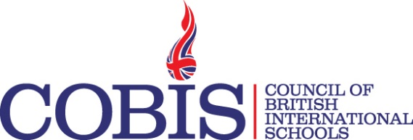
Webinar Title | Keeping Children Safe In Education Update
Webinar Date | 29/01/2019
Webinar Time | 13.00 UK Time
Target audience | Head Teachers, Deputy Head Teachers, Safeguarding Leads and other members of the safeguarding team.
Learning outcomes | - Informed understanding of new KCSIE  - Practical advice and implementation understood  - Any individual questions or concerns addressed  - Up to date with what needs to be done to remain compliant with changes
Webinar Description | In this webinar our Director of Safeguarding Services, Mike Glanville, will give an overview of the changes included in the newly released statutory guidance Keeping Children Safe in Education. He will also be giving practical advice which schools can follow to ensure they are operating within the new guidance. There will be a question and answer session where members can be confident that they are receiving well-informed and accurate answers to their queries from an expert in the fields of child protection and safeguarding. Members will also benefit from a number of free resources designed to guide them through the changes.
Presenter  Biography | Mike Glanville is the Director or Safeguarding Services for One Team Logic, the company behind safeguarding software MyConcern.  Mike’s background is in policing, he was the Assistant Chief Constable with Dorset Police up until May 2012. Earlier in his career Mike was a trained Child Protection Investigation Officer and as the Head of CID he had overall responsibility for all child and adult safeguarding issues.  Throughout his career Mike led on a number of critical incidents and major crime investigations involving vulnerable children and adults. Mike was the chair of the Local Criminal Justice Board in Dorset and represented the police at the Local Children’s Safeguarding Board.  Mike is an experienced school governor having been the Chair of Governors at 2 schools in Dorset since 2008. He is currently the Chair of a small primary school in West Dorset. In his role as Chair of Governors he has overseen the rapid improvement of one school from ‘Requiring Improvement’ to ‘Outstanding’ in less than two years. He has also been called upon by the Salisbury Diocese Board of Education (SDBE) to provide on-going support and advice to school Governing Bodies as part of a self-improving governance group.  In his current role as Director of Safeguarding Services, Mike has responsibility for ensuring that safeguarding remains central to everything that we do at One Team Logic. Developing our own knowledge and expertise means that we are able to provide the very best support to customers.

