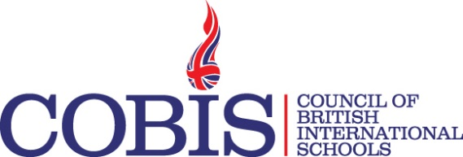
Webinar Title | How the GDPR applies to international schools and ways to achieve compliance
Webinar Date | 14th February 2019
Webinar Time | 1.00pm UK Time
Target audience | Senior leadership teams from COBIS schools, including business managers and bursars, those supporting alumni and HR teams, PAs and secretaries.
Learning outcomes | - To understand how the GDPR applies to their school.  - To be clear on the minimum requirements needed to demonstrate compliance.  - How to understand and improve the data privacy culture of their school.  - To understand what constitutes a data breach and how to handle them.  How to respond to data subject access requests.
Webinar Description | This webinar will explain how the GDPR applies to international schools and what schools must do to demonstrate compliance. We will outline the key changes and the increased accountability placed on all organisations. The webinar will focus on relevant school-based scenarios and examples such as managing data processing consent for the over 13s.  We will consider the rights of data subjects and how to ensure they are met including the right of access and how to deal with a subject access request.  We will outline what constitutes a data breach and what the school should do if it experiences one. We will explain what data when breached can risk the rights and freedoms of data subjects and therefore need to be reported to the appropriate supervisory authority.  The webinar will explore the idea of a privacy culture and how schools can help staff to understand their day-to-day responsibilities when handling personal data.
Presenter  Biography | Claire Ashton is sector marketing manager for education at IT Governance and a GDPR Practitioner. She has worked in the education sector for over 20 years, as a teacher and for various education technology companies. At IT Governance, she is responsible for marketing to the education sector including adapting solutions to meet its specific needs.

