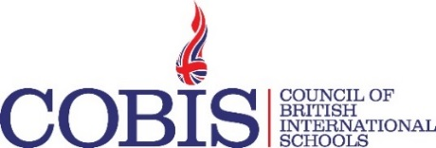
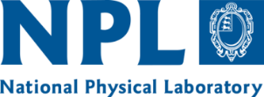
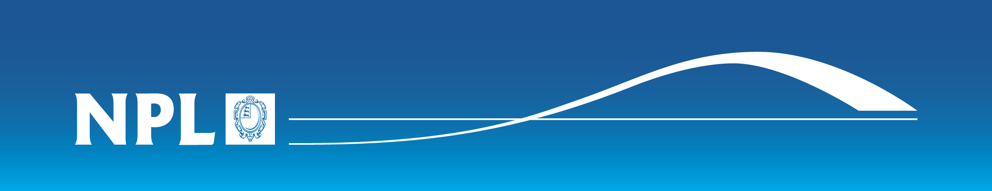
VIDEO RELEASE FORM
COBIS young scientist film Awards
SCHOOL NAME (“School”):
NAME OF CONTACT:
NAME OF VIDEO(S):
COBIS has partnered with the National Physical Laboratory (“NPL”) (together, the “Partners”) in London to run the COBIS Young Scientist Film Awards (the “Competition”). In consideration of the opportunity to take part in the Competition, I, on behalf of the School, understand and agree to the following:

- I confirm that I have the right to enter into this Agreement on behalf of the School and that I am not restricted by any commitments to third parties, and the Partners have no financial commitment or obligations to me, or the School, as a result of this Agreement.

- I confirm that, in uploading the above mentioned video(s) (the “Video(s)”), I have ensured all parents/caregivers of the children who appear in the Video(s) have agreed to their child’s image being made publically available for the purpose of the Competition.

- I confirm that any and all material contained in the Video(s) is either owned by the School or otherwise authorized for such use without obligation.

- I agree that the Partners may use the Video(s) (in whole or in part) for any purpose relating to the Event and the School grants the Partners the right to use, copy, edit, duplicate, copy, broadcast and exhibit the Video(s) for this purpose.

- Notwithstanding the above, the School retains a licence to use the Video for its own publication.

- I expressly release and indemnify the Partners and their officers, employees, agents and designees from any and all claims known and unknown arising out of, or in any way connected with, the above granted uses and representations. The rights granted herein are perpetual and worldwide.

- The information provided in this form is used for the administration of the Event and is managed and stored in accordance with the UK Data Protection Act 2018. NPL has a Data Privacy Policy which can be found at [http://www.npl.co.uk/privacy-policy/].

- This Agreement shall be governed in all respects by English Law.

By signing this Agreement I acknowledge that I have completely read and fully understand the above conditions and agree to be bound thereby.

If you wish to withdraw consent, please contact DataProtectionOfficer@npl.co.uk

Name _____________________

Signature _____________________

Date _____________________

