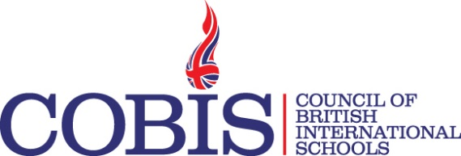
Webinar Title | Thinking about the COBIS Diploma for International TAs as a Professional Development Tool for your School?  In association with The Teaching Assistant College
Webinar Date | 13th November 2018
Webinar Time | 1pm UK Time
Target audience | Headteachers, CPD Leaders and TAs considering the COBIS Diploma for International Teaching Assistants (DITA) and DITA Early Years.
Learning outcomes | - Overview of the DITA content for main school and early years TAs  - Course content and relating theory to practice  - Expected impact on classroom practice  - Relevance for International Teaching Assistants  - Suitability for TAs with English as an Additional Language  - Assessment criteria and expectations to achieve pass, merit and distinction outcomes
Webinar Description | This webinar is for Senior Leaders, Professional Development Co-ordinators and Teaching Assistants, Learning Support and Line Managers of Support Staff considering the COBIS Diploma for International Teaching Assistants to enhance the professionalism of the TA team, their impact on teaching and learning in addition to developing confidence in their role.  The COBIS DITA and DITA for Early Years have six units each, directly relevant to the role of the TA and designed to teach strategies to transform practice and develop reflection.  I just want you to know what an amazing program you are offering. I have learned so much this year and have been able to apply my learnings at school and at home. Thank you for your positive encouragement, leadership and support throughout each unit and I'd like to continue with COBIS training in the near future.  Allyson Van Eldik Thieme
Presenter  Biography | Eva Cartwright is Founder and Principal of The Teaching Assistant College.  She has been working closely with schools to raise the profile and standards of teaching assistants for over 16 years and with a background in primary teaching fully understands the difference well trained teaching assistants can make. Eva has a passion for supporting teaching assistants to be creative in their approach, focussing on the things that really matter such as building independence, self-esteem and confidence as well as delivering effective support through understanding children’s needs and individual differences.  The Teaching Assistant College is a provider of CACHE accredited qualifications, INSET, short courses and bespoke training packages. Eva supports schools in looking at all aspects of the TA role from observing practice to analyse gaps in practice, improve the working relationship between teachers and TAs, performance management and development through coaching. #AllThingsTA  Twitter: eva_cartwright  LinkedIn: http://uk.linkedin.com/in/EvaCartwright  blog.tacollege.com  www.tacollege.com

