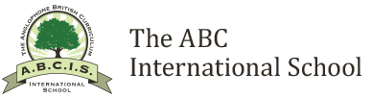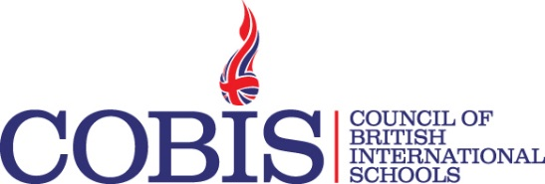

Want to take a GAP Year between Sixth Form and starting University?

Have you a genuine love of young children?

Interested in working in a
FOBISIA / COBIS
member School?

The ABC International School, Ho Chi Minh City Vietnam, is pleased to offer up to two GAP Year placements or internships to fluent English speaking students that are about to graduate from a FOBISIA or COBIS School and who would like to work as a part of the teaching assistant team in our vibrant learning community.

Interested candidates:
- Will be expected to make a full and active contribution to all aspects of school life at our Key Stage 1 and EYFS campus for one academic year commencing August 2016 and ending early July 2017.
- Should send a brief letter of application explaining their interest and why they think they could be a successful appointment to recruitment@theabcis.com This statement should also be supported by a detailed CV that includes the names and contact details of three referees. The closing date for expressions of interest will be Friday, June 17th 2016.

In return successful candidates will:
- Have the opportunity to work as a part of a highly qualified and experienced teaching team in what is recognised and accredited by the UK government as both an “outstanding” but also “teaching school” that is able to support and develop aspirant teachers.
- Receive a competitive Remuneration/Benefits package that will include in- and out- bound flights at the start and end of contract, free accommodation, and a generous monthly pocket-money allowance.
- Have the opportunity to work and build life-long memories with some truly wonderful young people whilst working in one of the most vibrant cities in Asia.

~~ Get in touch ~~
We will look forward to hearing from you.
recruitment@theabcis.com

