MOSCOW’S YOUNGEST SCHOOL PRINCIPAL (but only for a day !)

Despite the fact that we are an English International School, and a very new and small school serving the international community in Moscow, we have been developing our curriculum to ensure our programme include leadership opportunities for our students. We decided to ask the Principals Australia Institute if we could join in with their scheme Student Principal for a Day (www.sp4d.edu.au/) and were delighted that they agreed so that EIS Moscow South-West became the first school outside Australia to register as participants.

In a scrupulously fair election after hustings, our one and only Australian student – Nic in Year 5 – was elected as Student Principal and given our size we decided that the other members of Years 5 and 6 would be Vice Principals for the day.

A programme of activities involving Nic throughout the day, and the Vice Principals at various times ensured that our Student Principal and his team managed to cover all parts of the school. The programme included lesson observations, sending an email to all parents reminding them about the school photo the next day, meetings with the PTA Representatives and a Skype conversation with a representative of our group Head Office in Manchester - Orbital Education. We could not fit everything in on the day so other plans included giving a guided tour of the campus to the Australian Consul later in the week.

It turned out to be a fantastic day and when our Secretary went into class before the day to ask Nic what biscuits he would like to have whilst Principal and whether he prefers tea, coffee or juice when at the Principal’s desk – some of his peers could see that there are actually some privileges being Principal.

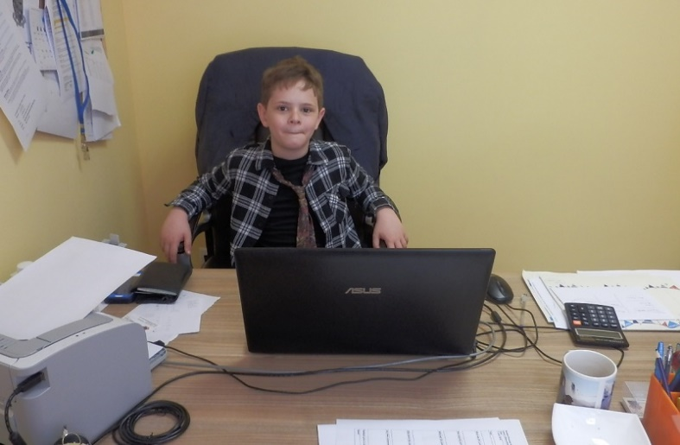

So what did the children learn from this ? Perhaps it is best to ask Nic to sum up the experience : “I especially enjoyed observing lessons. I was able to see how the children worked in class and how the age of the child altered the style of the lessons. It was a great day !”

Thanks to Principals Australia Institute for allowing us to take part – and next year, we very much hope they will let us join them, despite the extra work we caused.

